**Resume**

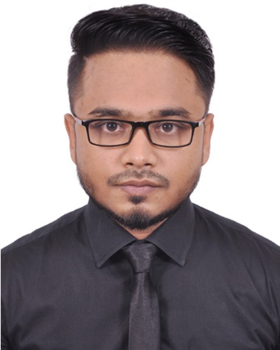

**Of**

**Tanvir Hossain**

call-512.png**January 4th, 1996, Bangladesh**

Cell: +88 01879252861

****email-icon.pngEmail: tanvir0emon@gmail.com

<https://www.linkedin.com/in/tanvir0emon>



**Career Objectives**



**Academic Qualification**



**Computer Skill**



**Experience**

Seeking a challenging career opportunity in a reputed company where I can harness my education, technical skills and creative towards making significant contribution to the growth and development of the company and thereby develop myself.

|  |  |  |  |  |
| --- | --- | --- | --- | --- |
| **Examination** | **Institution** | **Concentration/Major** | **Result** | **Passing Year** |
| B.Sc. (Engineering) | Daffodil International University | Electronics & Telecommunication Engineering | **2.88** out of CGPA-4 | 2019 |
| H.S.C | Dhaka Bigyan Collage | Science | **3.50** out of GPA-5 | 2014 |
| S.S.C | Rampura Ekramunnessa High School | Science | **4.44** out of GPA-5 | 2012 |

Programming Language : HTML5, CSS3(Bootstrap, Tailwind), JavaScript (Vue Js), and

PHP (Laravel, Nova).

Operating System : Windows 8, Windows 10, mac OS.

Application Package : MS Excel, MS PowerPoint, MS Word.

Engineering Software : MATLAB, Cisco Packet Tracer, and VMware Workstation

**1.** Company: 999 It Solution.

Position: Backend Developer(intern).

**2.** Company: Samsung Bangladesh.

Position: Samsung Experience Consultant.

**3.** Company: Global Brands Ltd.

Position: Marketing Executive.



**Experience**



**Soft Skill**



**Language**

**Proficiency**



**Extra**

**Curricular Activities**



**Personal Information**



**Declaration**



**Reference**

Have a quality for adopting new concepts of studies as well as responsibilities. Easily get involve with the new people. Good explanation skills. I believe, I have the capability of convincing people. I would be able to work under pressure and strain. I am able to successfully meet the crucial challenge of the work place.

|  |  |  |  |
| --- | --- | --- | --- |
| Language | Reading | Writing | Speaking |
| English | Excellent | Excellent | Good |
| Bangla | Excellent | Excellent | Excellent |

* I was a member of “ETE SPORTS CLUB”.
* I am an active member of “YOUNG PEOPLE IN CHANGING WORLD”
* I was a member of DIU project club.

Father’s Name : Delowar Hossain

Mother’s Name : Sherin Akter

Gender : Male

Marital Status : Unmarried

Nationality : Bangladeshi by birth

National Id No. : 6900968733

Religion : Islam

Blood Group : B+ ve

Permanent Address : Kurbanpur, Muradnagar, Cumilla

Mailing Address : 176/19, (Nur Jahan Vila) Ulon, West Rampura, Dhaka-1219

*I declare that the information provided here is correct, true and complete to the best of my knowledge and belief*.

Sincerely Yours



**Tanvir Hossain**

**Md. Jahid Hasan**

Admin & HR

Advent Pharma Ltd.

Mobile: +88 01718-233079

Email: jahid1979@gmail.com